**PROJECT REPORT**

**ON**

**KNOWLEDGE AND FUN WITH WORLD MAP**



**Submitted to Punjabi University, Patiala**

**In fulfillment of the requirement for the degree of**

**Master of Computer Applications**

**MCA 3rd SEMESTER SESSION (2017-18)**

**SUBMITTED TO SUBMITTED BY**

**Dr ________________ ABC Singh**

**(150987654)**

**KNOWLEDGE**

**AND**

**FUN WITH WORLD MAP**

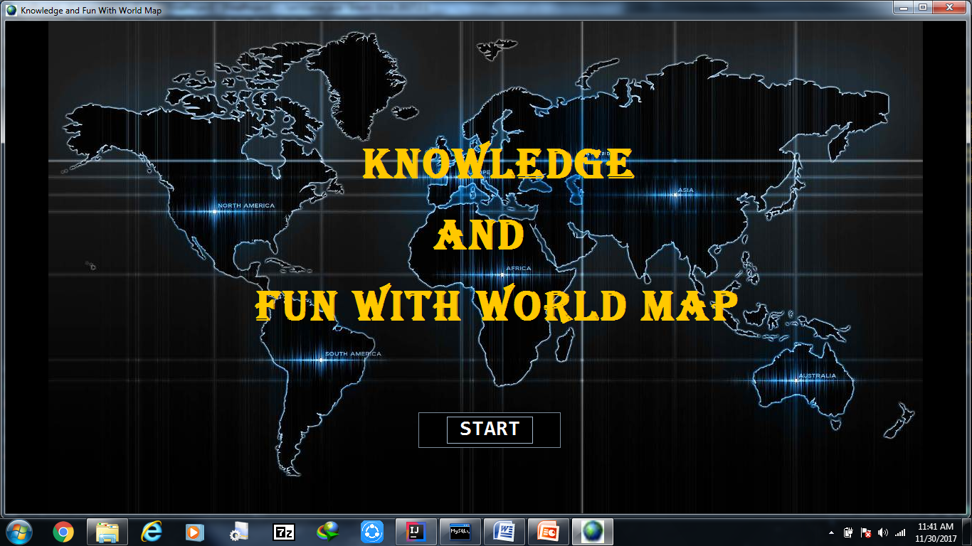

**CERTIFICATE**

This is to certify that this project “ KNOWLEDGE AND FUN WITH WORLD MAP ” submitted to Punjabi University Patiala in fulfillment of the requirements for the degree of Master Of Computer Applications is carried out by BBB Singh under my guidance and supervision and no part of this work has been submitted for any other degree . The assistance and help received during the course of work has been fully acknowledged.

PROJECT GUIDE

Dr. ____________________

Dr. ____________________

**ACKNOWLEDGEMENT**

The author would like to take this opportunity to express gratitude to all those people without whom this project could have never been completed. First and foremost author would like to express deep sense of thanks and gratitude to his mentor, teacher and guide Dr ____________ , his dedication and keen interest above all his overwhelming attitude to help his students had been solely and mainly responsible for completing this work.

The author thanks profusely to other faculty members of computer science department of Punjabi University Patiala for their intellectual support throughout the project.

Last but not the least author would like to thank his parents for their inexhaustible source of inspiration.

BBB Singh

Date: 30.12.2017

**ABSTRACT**

The project KNOWLEDGE & FUN WITH WORLD MAP is a game based learning software for gaining knowledge about countries and testing knowledge about them. This mainly focuses on exploring informative details about countries and has a check on how much we know about countries. This project gives knowledge about various countries, national anthems, area covered, where located on map etc.

**TABLE OF CONTENTS**

|  |  |  |
| --- | --- | --- |
| SR.NO | CONTENTS | PAGE NO. |
| 1 | Introduction:   * 1. Purpose   2. Intended Audience   3. Product scope   4. Project Features   5. Feasibility   6. System Requirement   7. Hardware/Software Requirement | 1-3 |
| 2 | System Development  2.1 Project Management  2.2 System Analysis And Design(DFD)  2.3 System Environment | 4-6 |
| 3 | Design And Implementation:  3.1 Classes Used And There Structure  3.2 Database Design  3.3 Snapshots Of System | 7-14 |
| 4 | Testing:  4.1 Verification  4.2 Validation  4.3 Testing  4.3.1 Black Box Testing  4.4 Test Cases  4.5 Results Of Different Tests | 15-17 |
| 5 | Project Legacy  5.1 Current Status  5.2 Problems Faced  5.3 Limitations  5.4 Future Enhancements  5.5 Conclusion | 18 |

**INTRODUCTION**

* 1. **PURPOSE**

The main purpose of this project is to give knowledge about various countries national anthems, area covered, where located on map etc. This project will save time and will help to explore your specific country on just one click.

* 1. **INTENDED AUDIENCE**

Mainly intended audience of this system is kids but anyone who want to know about country or want to play game for entertainment can use this project.

* 1. **PRODUCT SCOPE**

This project is for desktop computers and does not need any internet connection to work hence, this is an offline project. This system can be deployed in small schools to make small kids learn fast and enjoy.

* 1. **PROJECT FEATURES**

**1.4.1 CROSS PLATFORM SUPPORT:** Offers operating support for most of the known and commercial operating systems. Ex Linux, windows 7,8,10 etc.

* + 1. **INTERACTIVE:** Provideseasy interactive interface .
    2. **EASY:** Simple to understand .
    3. **FRIENDLY:** Gives user friendly environment.
    4. **OPERATABILITY:** Any one can operate.

**1.5 FEASIBLITY**

**1.5.1 Technically Feasible:** As the technical skills required for the development of the software is available with the software developers. Technology used is available worldwide and it’s easy to make this software possible with help of swings.

**1.5.2 Economically Feasible:** As the product is not requiring any extra cost of any other highly equipped or paid software's or hardware’s for the development therefore my software is economically feasible.

**1.6 SYSTEM REQUIREMENTS**

For this system internet surfing was done and books were seen to check what major information should be available in this system. The game will give two options one to explore and other one for brain test. Explore will provide us with countries and their information and brain test will give us two games like plotting countries on map And match the following.

* + 1. **FUNCTIONAL REQUIREMENTS**

**use case 1:** choose a country to see information

**diagram:**

Information

Choose Explore

Select a country flag

**Brief description:** user chooses explore option then selects the country flag to see country information

**Step by Step description:**

Step 1 - user clicks on the explore button.

Step 2 - list of countries and their respective flags are shown.

Step 3 - user clicks on a country flag.

Step 4 - country information is fetched from database and is shown.

**use case 2:** choose game 1 to play identify countries game.

**diagram:**

Choose brain test

Identify and Type country names

Select game 1

Show result

**Brief description:** user chooses brain test option then selects the game 1 identifying the countries to play.

**Step by Step description:**

Step 1 - user clicks on the brain test button.

Step 2 - clicks on identifying countries button.

Step 3 - identifies country on map.

Step 4 - type names in text fields.

Step 5 - answers are checked and results are shown.

**use case 3:** choose game 2 to play match the following game.

**diagram:**

Match part a and b i.e write answers in text fields

Choose brain test

Select match the following

Show results

**Brief description:** user chooses brain test option then selects the game 2 match the following to play.

**Step by Step description:**

Step 1 - user clicks on the brain test button.

Step 2 - clicks on match the following button.

Step 3 - identifies correct option of part a in part b.

Step 4 - type numbers in text fields.

Step 5 - answers are checked and results are shown.

**1.6.2 NON_FUNCTIONAL REQUIREMENT**

This project is having following non-functional requirements:-

**Maintainable -** it should be easy to maintain.

**Usable -** thesoftware should be usable for the general user.

**Understandable -** is easily understandable.

**Interactive -** should be interactive.

* 1. **HARDWARE / SOFTWARE REQUIREMENTS**
     1. **Hardware Requirements**

Simply a device such as Laptop ,pc ,mouse ,keyboard etc.

**1.7.2** **Software Requirements**

For running - JVM (java virtual machine), JRE (Java run time environment).

For Development - The whole project work will be developed in intelliJ IDEA 2.0. This is a premier IDE (Integrated Development Environment) for Java. Therefore, specific requirement is mainly intelliJ IDEA 2.0, JDK SE 8.

**SYSTEM DEVELOPMENT**

**2.1 Project Management: Gantt Chart**

|  |  |  |  |  |  |  |  |  |
| --- | --- | --- | --- | --- | --- | --- | --- | --- |
| **PHASES** | **Day**  **1** | **Day**  **2** | **Day**  **4-9** | **Day**  **10-15** | **Day**  **16-20** | **Day**  **21-25** | **Day**  **26-28** | **Day**  **29-30** |
| **PLANNING** |  | | | | | | | |
| **REQUIREMENTS**  **ANALYSIS** |  | | | | | | | |
| **DESIGN** |  | | | | | | | |
| **CODING** |  | | | | | | | |
| **TESTING** |  | | | | | | | |
| **IMPLEMENTATION** |  | | | | | | | |

**2.2 SYSTEM ANALYSIS AND DESIGN**

**2.2.1 DFD LEVEL 0 (CONTEXT LEVEL)**

GIVE INFORMATION

OR

GAME RESULT

INFORMATION OR

GAME

USER

CHOICE

**2.2.2 DFD LEVEL 1**

USER CHOICE

HOME

MENU

EXPLORE

SHOW INFO

OR

SHOW GAME RESULTS

BRAIN TEST

**2.2.3 DFD LEVEL 2**

USER CHOICE

SHOW RESULTS

EXPLORE

GAME PROCESS

CHOOSE GAME

HOME

MENU

EXTRACT DATA

SHOW DATA

BRAINTEST

**2.2.4 DFD LEVEL 3**

USER CHOICE

USER WILL GUESS THE COUNTRY AND TYPE ITS NAME ON MAP

IDENTIFY COUNTRY ON MAP

SHOW RESULTS

RANDOMIZER WILL GENERATE PART A & PART B

MATCH THE FOLLOWING

USER WILL FILL PART A NUMBERS IN PART B

**DESIGN AND IMPLEMENTATION**

**3.1 CLASSES AND VARIABLES USED**

Menu

Game

path: String

Menu( )

Game( )

+ main( )

Explore

Anthem: String

L_x, L_y, L_z: int

Count: int

Conn: Connection

Stmt: Statement

BrainTest

ANS_1,ANS_2,ANS_3,ANS_4,ANS_5: int

ans_1,ans_2,ans_3,ans_4,ans_5: int

Conn: Connection

Stmt: Statement

WIN, LOSE, value, R_y, RESULT: int

FLAG: String

Explore( )

ShowCountriesInformation( ): void

GetDisplayCountryData( ): void

BrainTest( )

- MapShuffleCountries( ): void

- LaunchCountryGame( ): void

- EvaluateAnswersForGame1( ): void

- MatchShuffleCountries( ): void

- SwapPartB( ): void

- LaunchMatchGame( ): void

- EvaluateAnswersForGame2( ): void

**3.2 DATABASE DESIGN**

For this software MySQL database is being used.

**ID**

**NAME**

**DEMONYM**

**COUNTRY**

**CAPITAL**

**OFFICIALLY**

**HAS**

**NATIONAL**

**GOVERNMENT**

**OFFICIAL _LANG**

**EMBLEM**

**FLAG**

**ANTHEM**

**ID**

**SITUATED_MAP**

**CURRENCY**

**TOTAL**

**WATER_PERCENT**

**AREA**

**ID**

**HAS**

**ID**

**ESTIMATE**

**POPULATION**

**DENSITY**

**CENSUS**

**COUNTRY Data Entity**

|  |  |  |  |
| --- | --- | --- | --- |
| **Data Item** | **Type** | **Description** | **Constraints** |
| ID | Int | Id of the country | Primary key |
| Name | Varchar | Name of the country | Not Null |
| Capital | Varchar | Capital of the country | Not Null |
| Demonym | Varchar | Name of country people | Not Null |
| Officially | Varchar | Official name of country | Not Null |

**NATIONAL Data Entity**

|  |  |  |  |
| --- | --- | --- | --- |
| **Data Item** | **Type** | **Description** | **Constraints** |
| ID | Int | Id number of the national | Primary key |
| Flag | Varchar | Name of flag image file | Not Null |
| Situated_Map | Varchar | Name of location map image file | Not Null |
| Anthem | Varchar | Name of country anthem song | Not Null |
| Official_Lang | Varchar | Official languages of the country | Not Null |
| Currency | Varchar | Currencies of country | Not Null |
| Government | Varchar | Type of government in country | - |
| Emblem | Varchar | Name of emblem image file | Not Null |

**AREA Data Entity**

|  |  |  |  |
| --- | --- | --- | --- |
| **Data Item** | **Type** | **Description** | **Constraints** |
| ID | Int | Id number of area | Primary key |
| Total | BigInt | Total area of the country | unsigned |
| Water_Percent | Float | Total water quantity of country in percent | - |

**POPULATION Data Entity**

|  |  |  |  |
| --- | --- | --- | --- |
| **Data Item** | **Type** | **Description** | **Constraints** |
| ID | Int | Id number of area | Primary key |
| Census | BigInt | population in census | - |
| Estimate | BigInt | Estimated population | - |
| Density | Float | Density of population | - |

**3.3 SNAPSHOTS OF SYSTEM**



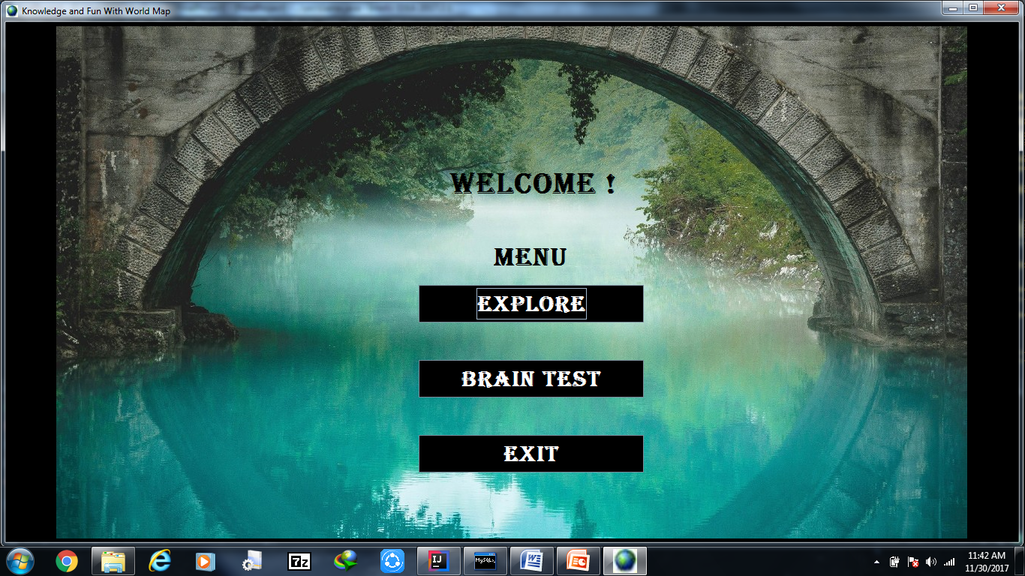

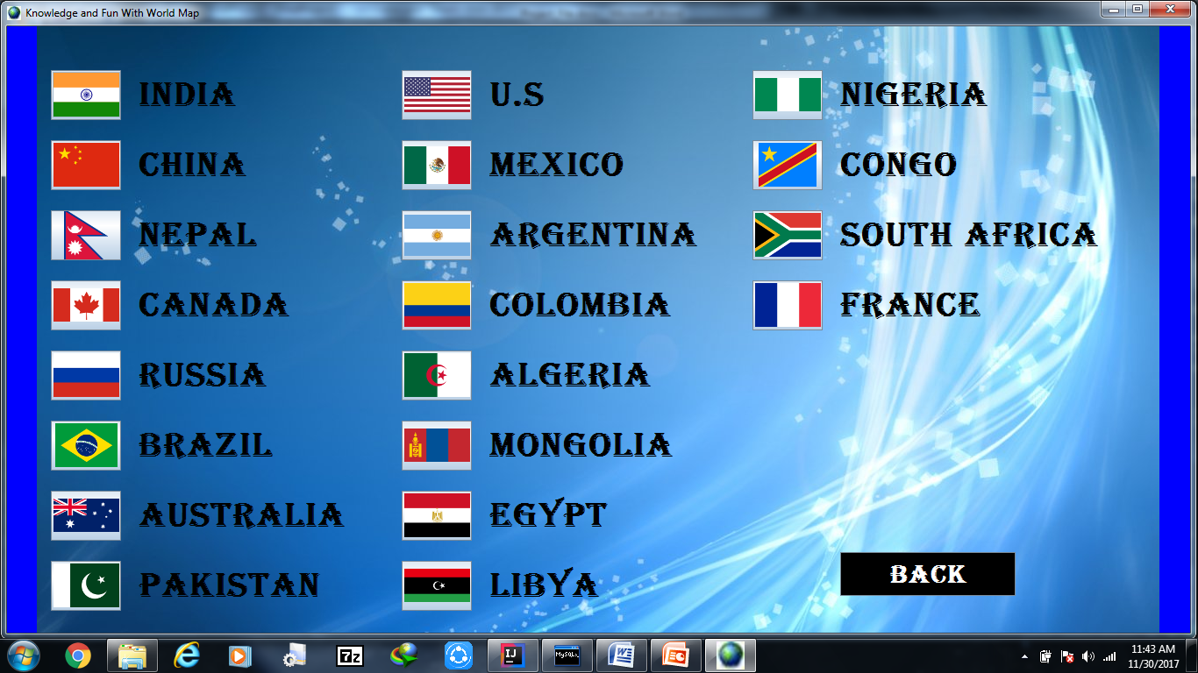

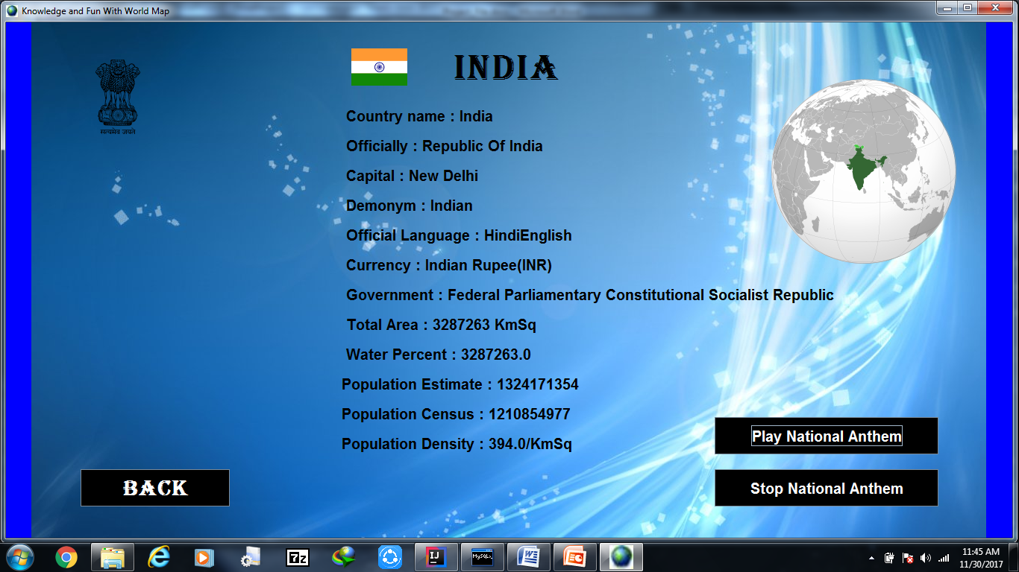

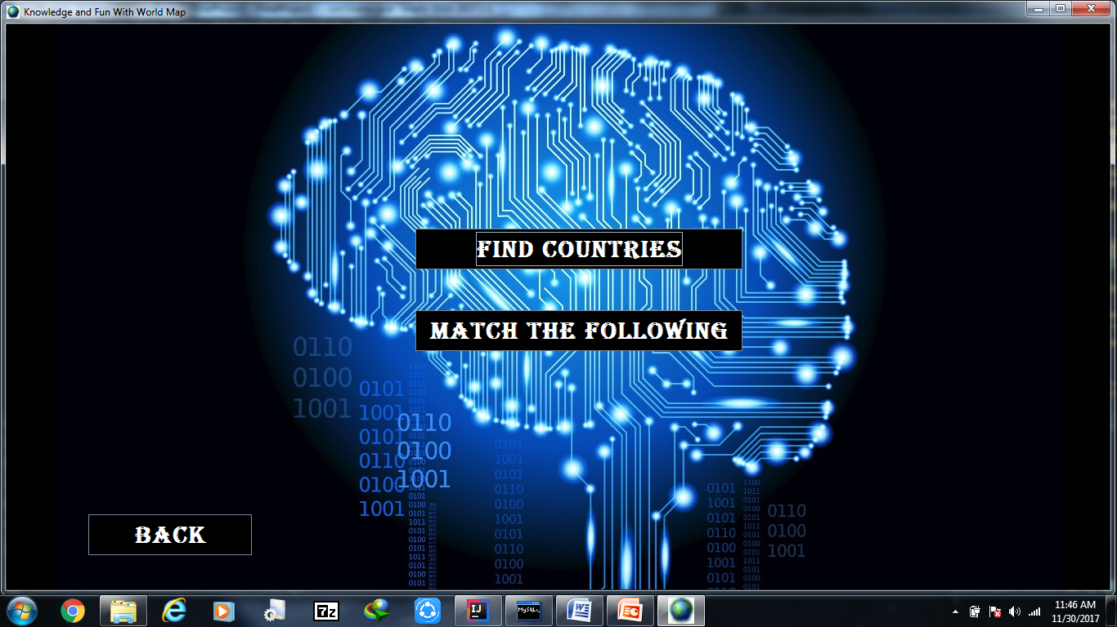

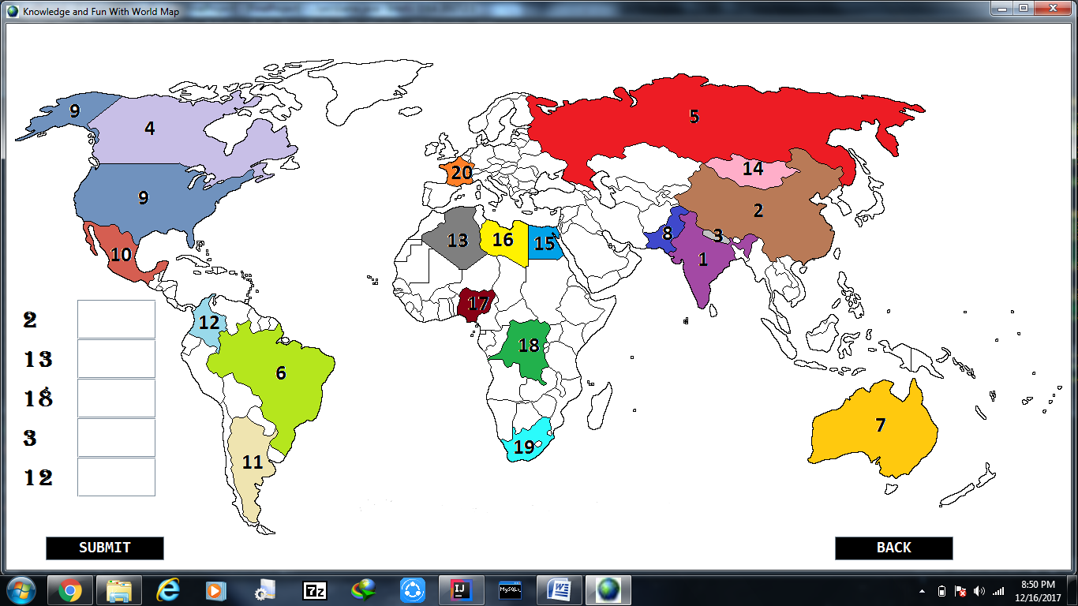

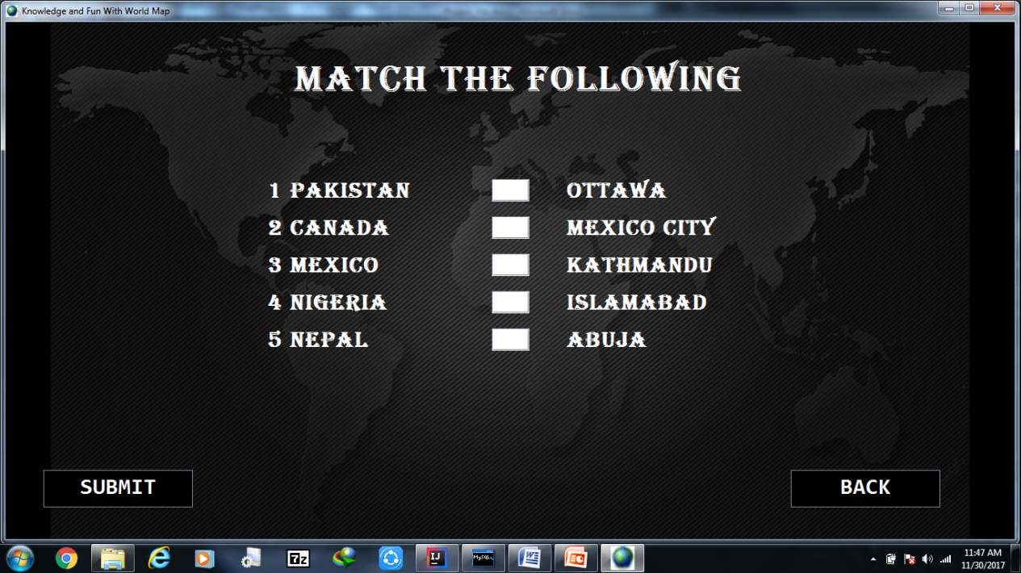

**TESTING**

**4.1 VERIFICATION**

To verify this software goal was to assure that software fully satisfies all the expected requirements. Here we determined whether the products of a given development phase satisfy the conditions imposed at the start of that phase. This was done by Static testing hence, by testing software without executing code such as review and static analysis.

**4.2 VALIDATION**

To validate this software goal was to assure that software fully satisfies all the specifications or specified requirements. The validation of this system is done with dynamic testing. This is done at unit and then at integration level.

**4.3 TEST PERFORMED**

**4.3.1 BLACKBOX TESTING:** In Blackbox testing the method which is used to test the software is Functional testing therefore, the system is tested against the functional requirements/specifications. Various main functions belonging to the software which is to be done by the software as stated in the requirement specifications are taken as test cases. Different test cases are prepared as mentioned here .these test cases are prepared as per functional point of view and equivalence class strategy in which if one set of value qualifies the test it is assumed that all the other same cases will result into same corresponding results.

**4.4 TEST CASES**

Test case id: 1

Test case description: clicking on country flag shows country information.

|  |  |  |
| --- | --- | --- |
| Step no | Step description | Expected result |
| 1 | Take mouse cursor on the respective country flag you want to choose. | Shows information of respective countries when clicked on the flag. |
| 2 | Click on the flag button. |

Test case id: 2

Test case description: showing WIN status result when given correct answers.

|  |  |  |
| --- | --- | --- |
| Step no | Step description | Expected result |
| 1 | Type the answers in the respective text fields. | If all answers are correct YOU WIN status should be shown on screen. |
| 2 | Click on the submit button |

Test case id: 3

Test case description: showing LOSE status result when given wrong answers.

|  |  |  |
| --- | --- | --- |
| Step no | Step description | Expected result |
| 1 | Type the answers in the respective text fields. | If all answers are not correct YOU LOSE status should be shown on screen. |
| 2 | Click on the submit button |

**4.5 TEST RESULTS**

|  |  |  |  |  |
| --- | --- | --- | --- | --- |
| Test performed | Input given | Expected output | Actual output | Result (pass/fail) |
| Clicking on country flag shows country information. | Clicked on a country flag | Show country information | Shows information of country | PASS |
| Show WIN result when given correct answers | Type answers and click on submit button | Show the result YOU WIN | YOU WIN result is shown | PASS |
| Show LOSE result when given incorrect answers. | Type answers and click on submit button | Show the result YOU LOSE | YOU LOSE result is shown | PASS |

**PROJECT LEGACY**

**5.1 CURRENT STATUS**

Project is completed as per requirements specifications. All functions specified are well prepared and is in working state at present. Just the number of countries included till now is 20. There are many more countries still left to be included in this software.

**5.2 PROBLEMS FACED**

Major problem faced during this project was to generate the match the following Part A and Part B randomly with both columns showing different results.

**5.3 LIMITATION**

Till now in this software only 20 countries are included there are many more left. Hence other countries should also be included in the list.

**5.4 FUTURE ENHANCEMENTS**

As for this project iterative enhancement model is used so therefore that any change in requirements could be handled. Enhancements like including other countries are to be made soon.

**5.5 CONCLUSION**

This game project is overall for entertainment purposes and can be well used to teach kids about countries.